Super Smash Bros. Tournament 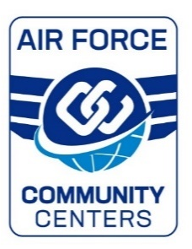
Registration

Name: ________________________________________
Email: ________________________________________
Telephone Number: _____________________________

- “BYDE” (bring your own equipment)
- We recommend you bring your own controller
- Please check which items/equipment you will bring

Monitor

Console

Controller

- Please return this registration either via e-mail to 86fss.ramsteincommunitycenter@us.af.mil or bring it to the Ramstein Community Center, Bldg. 412

